https://www.youtube.com/watch?v=YlR9AkDJMMA&list=PL9aNQqB-xjbAjGjkAKuydrYa8ZDM4TcI7
How to Create a Kubernetes Cluster in Azure?
Deployment , scaling and management of containerized applications

- Deployment controllers - for rolling out and rolling back applications
- Service discovery and load balancing – for exposing applications to the outside world
- Storage orchestration
- Self healing – for automatically replacing and rescheduling failed containers

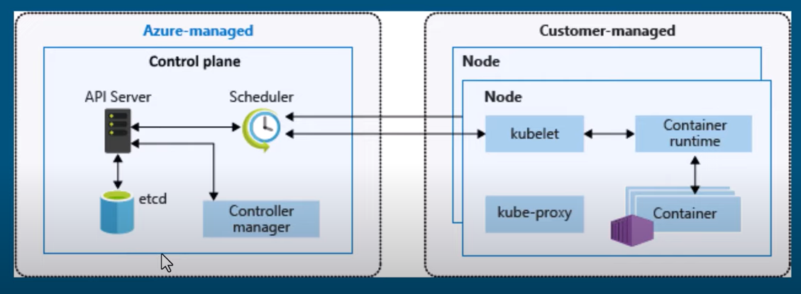

- Etcd – key value store for maintaining the state of kubernetes cluster
- Controller manager – for managing the various controllers that handle things like replication and self healing
- API server – for exposing the kubernetes API and interacting with the etcd store
- Scheduler – what nodes can run the workload and starts them

Worker node
- Kubelet for communicating with the API server and managing the life cycle of pods
- Container runtime – for pulling and starting containers on the node
- Kube proxy - for implementing the service networking model

Node Pool
- It is a set of virtual machine with same configuration
- System node pool : CoreDNS , metrics server , tunnel front and oms agent
- Node pool : Deploy applications

We need to add user node pool , by default a system node pool will be created already .

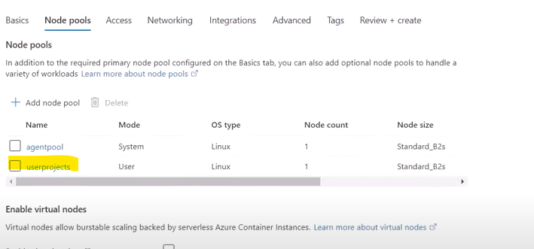

Using above commands you configure the kubernetes in the local machine .
Kubectl get pods --all-namespaces -o wide : it gives the details about all the pods including the one’s created under kube-system namespace .

How to deploy application to Azure Kubernetes | Azure Kubernetes tutorial for beginners

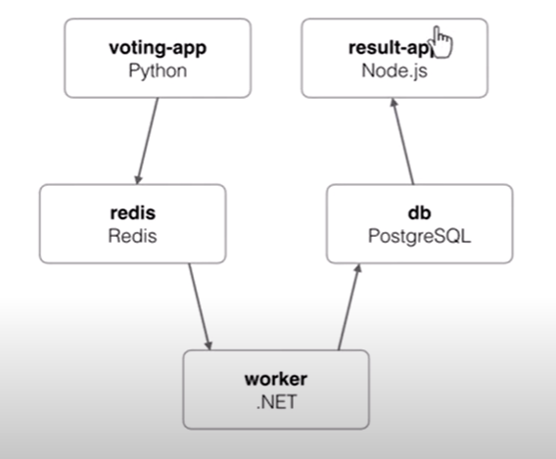

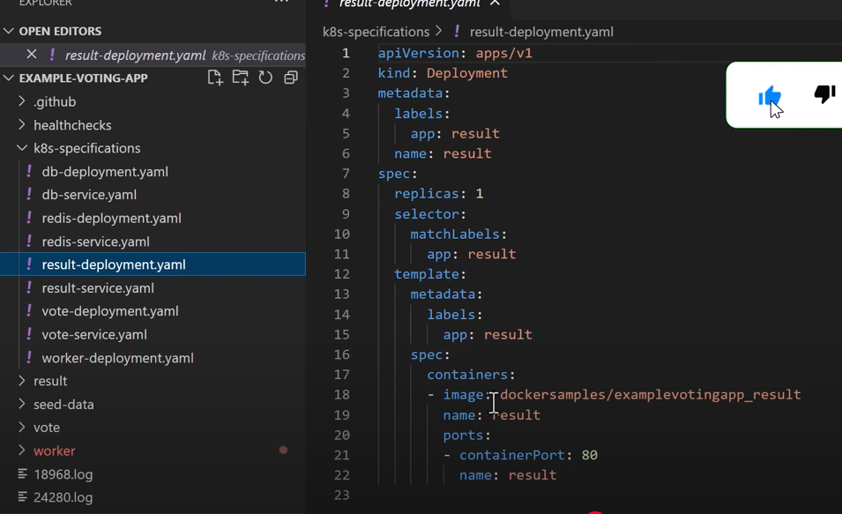

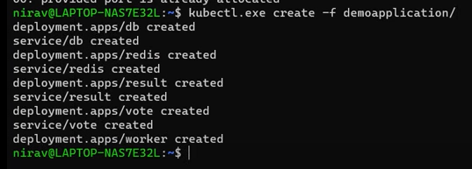

Kubernetes objects

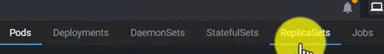

Pods : basic execution unit in Kubernetes is pod , it represents single instance of a containerized application . Pod is container or a group of containers .

We can use Lens Software to manage kubernetes cluster .

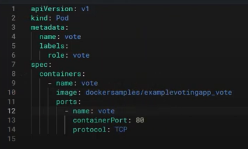

Deployment : It is a high level object that manages a Replication Controller or ReplicaSet and provide declarative updates to the application . With deployment you can specify the desired state of your application .

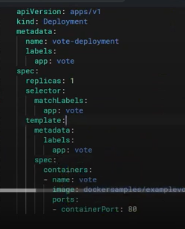

Replicaset – at any time , it runs 3 replica of application

Statefulset : It is used to manage stateful application , ex mysql , oracle and PostgreSQL

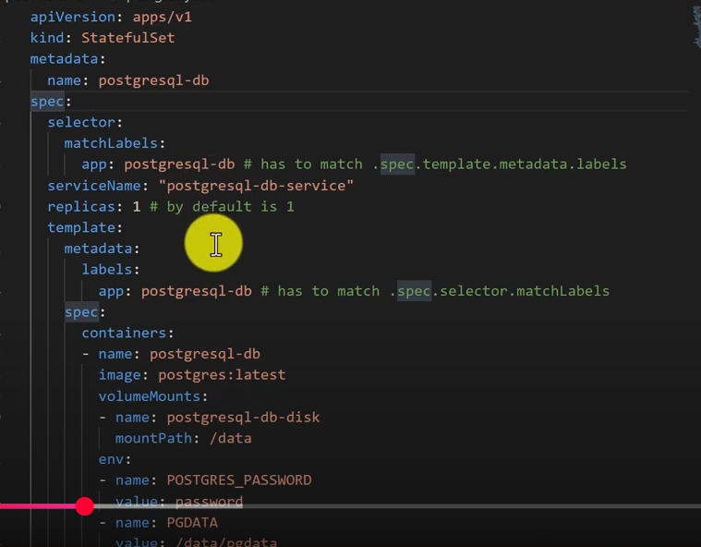

Even if some one removed , data is remained in the persistent volume .

Services :

Cluster IP : This type of service is the default and creates a stable IP address within the cluster , accessible only to the nodes and the other components . It is used for communication between pods .

Node Port : This service opens a static port on each node in the cluster ,forwarding traffic to the target pods

Load Balancer : This creates an external load balancer in the cloud providers infrastructure , forwarding traffic to the target pods
External Name : This type of service maps the service to an external DNS name , allowing it to be used as alias for another service or external resources .

Headless : It provides a cluster IP address for the service but instead uses the individual pod IPs .

DaemonSet : It ensures that a specific pod is running on all nodes in the cluster or on a subset of nodes as special . It needs to run on every node in the cluster such as logging agent or monitoring agent .

Jobs : Are used to run batch process or perform one-time tasks .

Optimizing Resource Utilization with Horizontal Pod Autoscaling (HPA) in Kubernetes

HPA is a control loop that continuously monitors the resource usage of an application and automatically adjusts the number of replicas to maintain a desired level of utilization .

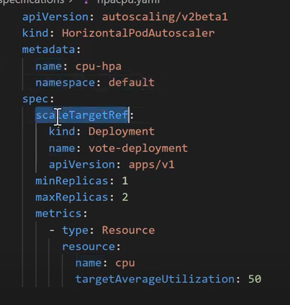

Upgrade Your Azure Kubernetes Version

Taints and Tolerations in Kubernetes

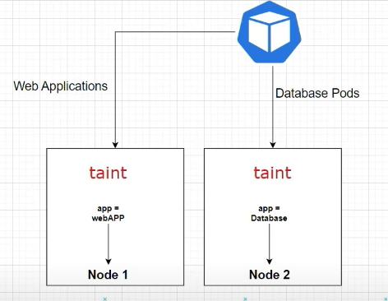

- Taints and Tolerations are used in Kubernetes to control which nodes can run which pods
- A taint is a label that is applied to a node , and it tells kubernetes that certain pods should not be scheduled on that node .
- A toleration is a way to tell kubernetes that a pod can be scheduled on a node even if the node has a taint that would normally prevent it from being scheduled there .
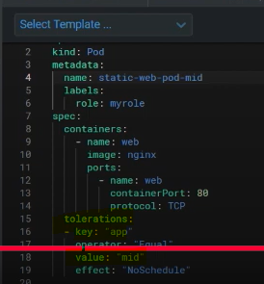

Node Selector in Kubernetes

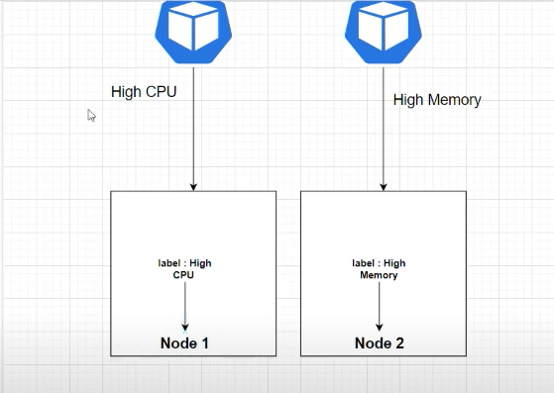

- Node selector is a powerful feature in Kubernetes that allows you to schedule your pods on specific nodes in your cluster based on node labels .
- Pods without matching node selector can still be schedule on labels nodes

Kubectl label nodes nodename capacity=high-cpunode/nodename labeled

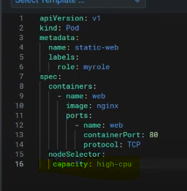

Understanding Affinity in Kubernetes

Affinity is a kubernetes feature that allows you to schedule your pods on specific nodes in your cluster based on various criteria , such as node’s labels , the pods labels , or pods anti-affinity

The different types of node affinity :
- Node affinity
- Pod affinity
- Pod anti-affinity

- Node affinity – It allows you to schedule your pods on specific nodes based on their labels .
- Pod affinity – Pod affinity allows you to schedule pods on nodes that are already running other pods that meet specific criteria.
- Pod anti affinity – It is opposite of pod affinity

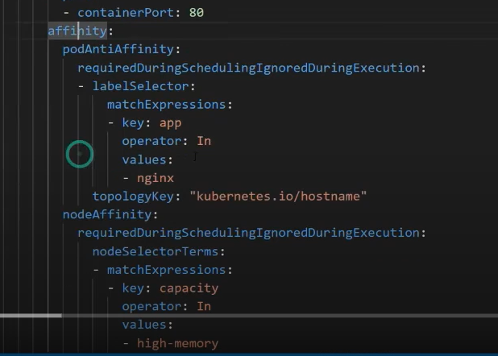

Secure Your Kubernetes Data with AKS Backup in Azure

AKS backup is a simple , cloud-native process to backup and restore containerized applications and data running in AKS clusters . It provides a reliable and scalable backup solution to protect against data loss or corruption .

Backup can be at the cluster level or at the namespace level .

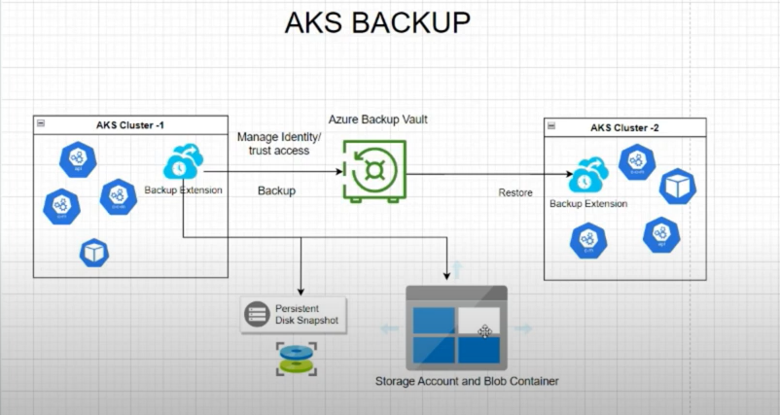

Pod Disruption Budget in Kubernetes

Pod does not disappear until someone (a person or controller) destroys them , or there is unavoidable software or hardware problem .

